Project Name- Decide Meal

1. Introduction
- While preparing a meal, the biggest question for a chef is “what to cook? “. Thus, website major targets are chefs that are unable to decide (“what to cook?”). The website will randomly generate a cuisine for the chef with all the ingredients listed required with instructions required to prepare it as well as video on cooking it.
- Goals: Help in decision making, simplicity and easily accessible.
- Benefits: Saves time for making decisions and time for searching for instructions elsewhere. For organizations such as Restaurants, the user can order the meal.
- Why Choose this project?- Because I was feeling hungry while doing the course and I had no idea what to cook for myself. Therefore, I ended up with this idea.

2. Design and Implementation
- The website was prepared according to the wire-frame design.
- Below are the wire-frame design and the logo for the website bot of them were implemented into the final website.
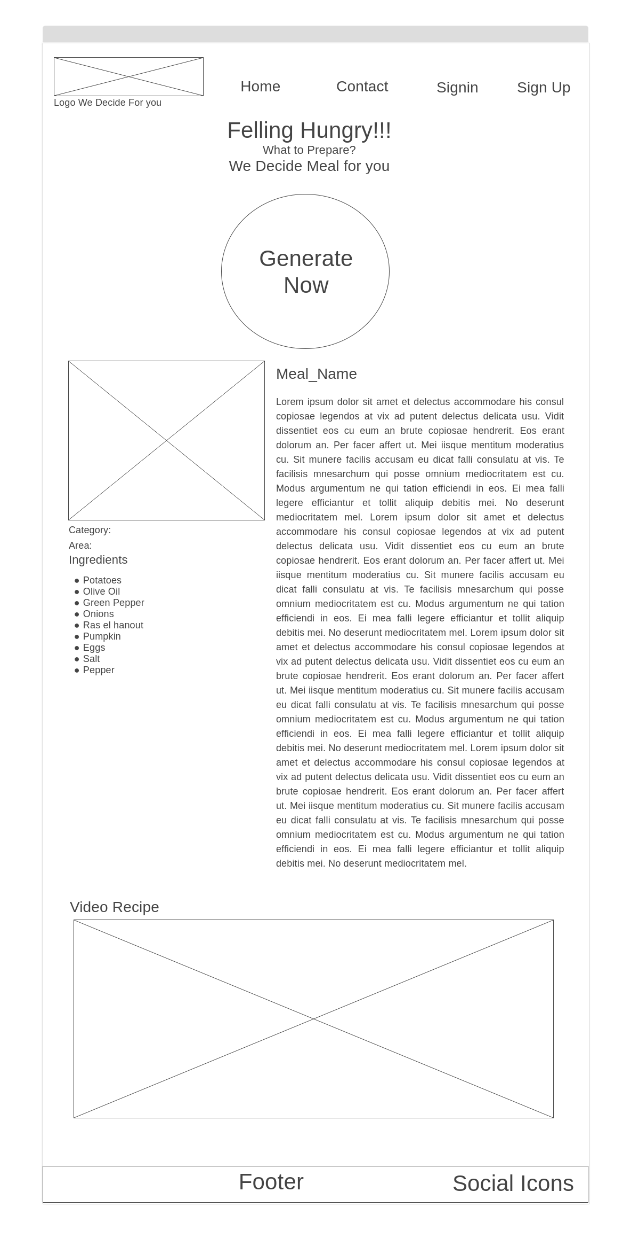


- The final implementation screenshots are below:
- The 3 images below are homepage screenshots.
- Image 1 is big screen screenshot and image 2 is for small screens.
- Image 3 shows the Sign-up modal in action
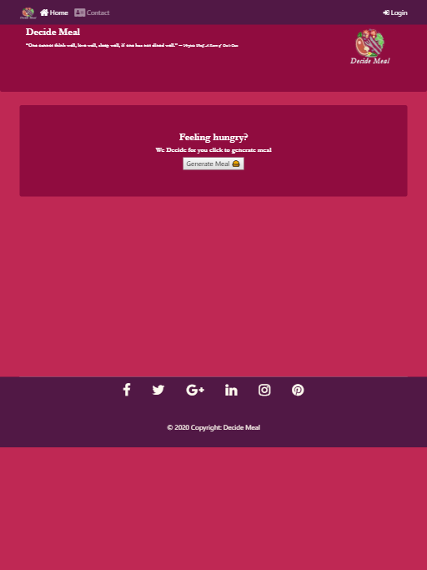
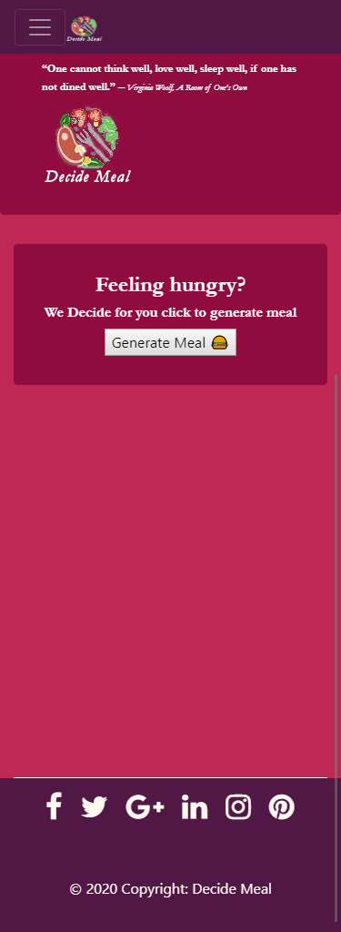
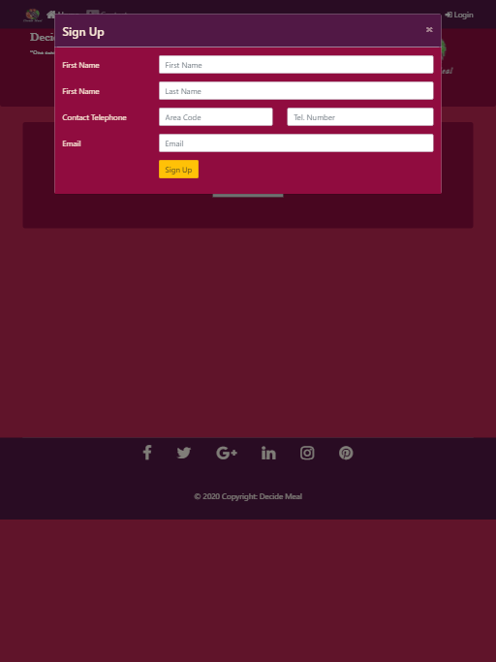

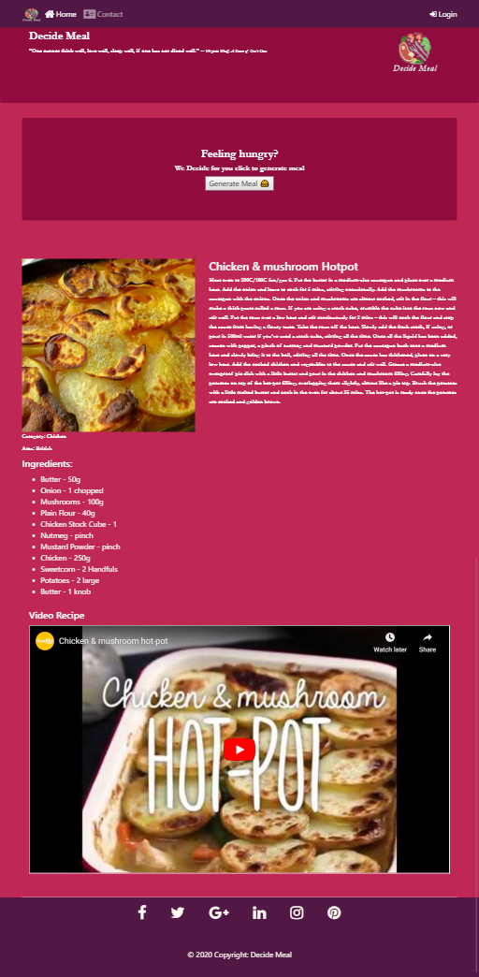
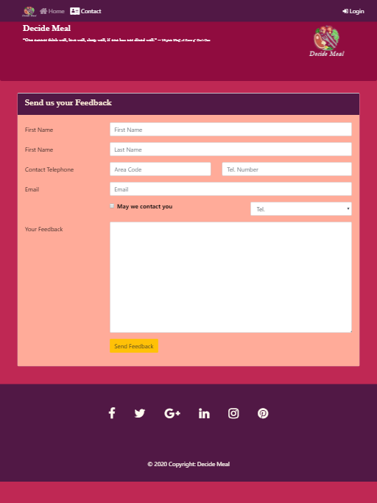
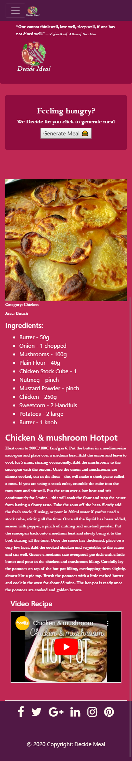
The above 2 images are screenshot when clicked on generate meal and output is generated.
- The third image of a feedback form on another web page for users to provide valuable feedback.

3. Conclusions
- I have used all the things I have studied during this course in this project preparation.
- Every time the user clicks generate meal a random meal will be listed for them .
- Shortcoming: I was unable to resolve the gap below footer, there are just 2 web pages

4. References
- FreeCodecamp: How to Create a Random Meal Generator by Florin Pop (https://www.freecodecamp.org/news/creating-a-random-meal-generator/)

